1. **Introduction**

**Analyzing Spending Behaviour and Indentifying For Growth**

Wholesaling or distributing is the sale of goods to retailer to industrial, commercial, institutional or other professional businessman to other wholesalers (wholesale businesses) and related subordinated services. Wholesaling is buying goods in bulk quantity, usually directly from the manufacturer or source, at a discounted rate. The retailer then sells the goods to the end consumer at a higher price making a profit**.**

The consumption and production of marketed food are spatially separated. Production of marketed food are spatially separated. Production is primarily rural areas while consumption is mainly in urban areas. In today’s highly competitive business landscape, gaining deep project aims to analyze customer spending behaviour and identify opportunities for growth by leveraging data analytics and data-driven decision-making.

The primary objective of this project is to understand customer spending patterns, preferences, and trends across various dimensions.. By conducting a comprehensive analysis, businesses can optimise their marketing strategies, improve product offerings, and enhance customer engagement to drive revenue growth.

**Purpose**

Market research provides critical information about your market and your business landscape. It can tell you how your company is perceived by the target customers and clients you want to reach. It can help you understand how to connect with them, show how you stack up against the competition, and inform how you plan next steps.

Market research can also play an important role in the process of developing your products and services, bringing them to the marketplace, and marketing them to consumers. Here are a few ways that market research can help inform your business strategy:

* It can give you an accurate view of your business and your marketplace. For example, you can see how you are perceived in comparison to your competitors, and evaluate what your competitors are doing attract customers.
* It can helps you determine who and where your customers are, and which customers are most likely to do business with you.(In fact ,for customers for indicate that they don’t want to do business with you ,market research is your opportunity to ask them ”why not”?

The competitive environment you face is increasingly challenging. Its safe to assume that your competitors are conducing research to gain their own advantages. That may be the best reason of all to make market a key part of your business growth strategy.

1. **Problem Definition and Design Thinking**

**Empathy Map**

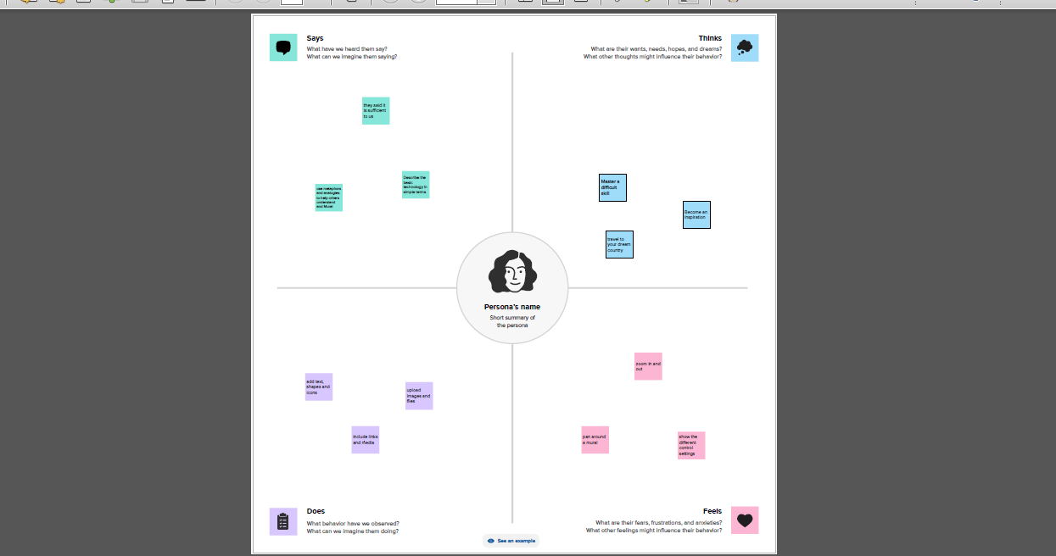

**BRAINSTORM AND IDEA PRIORITIZATION**

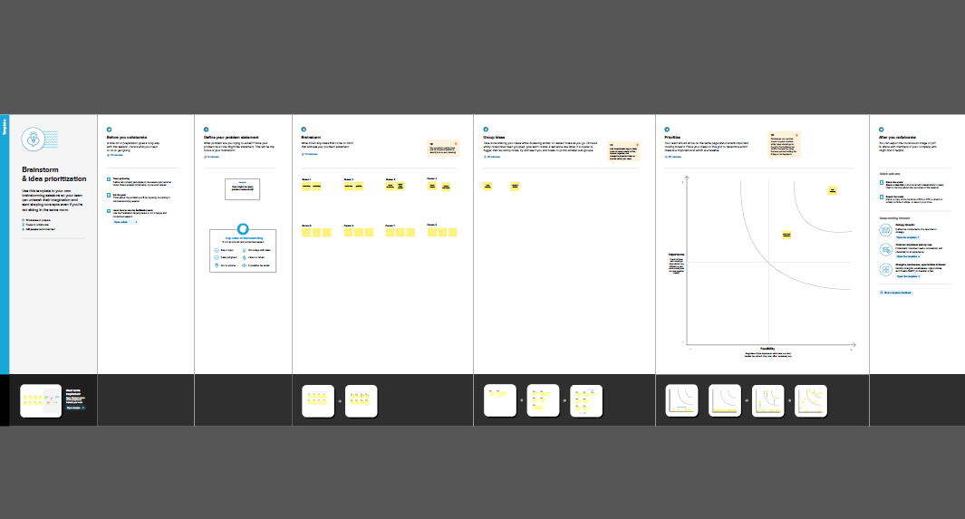

1. **RESULT**

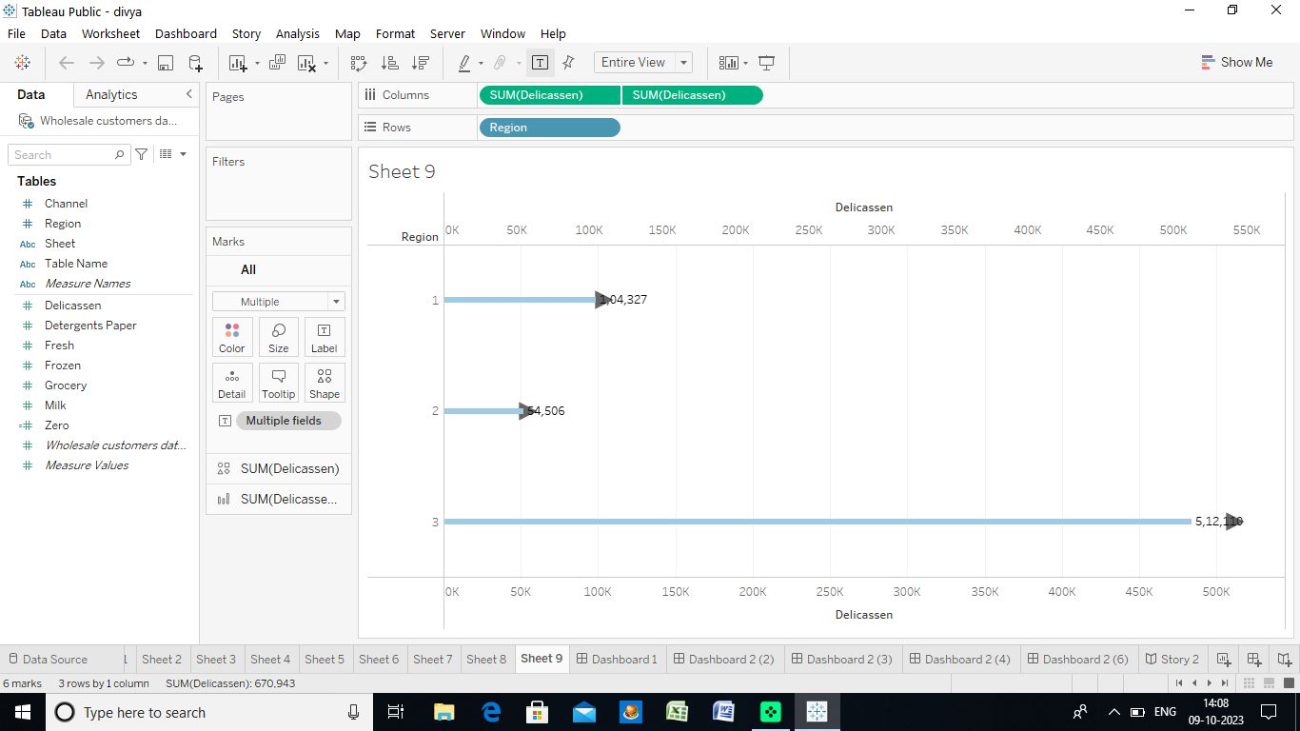







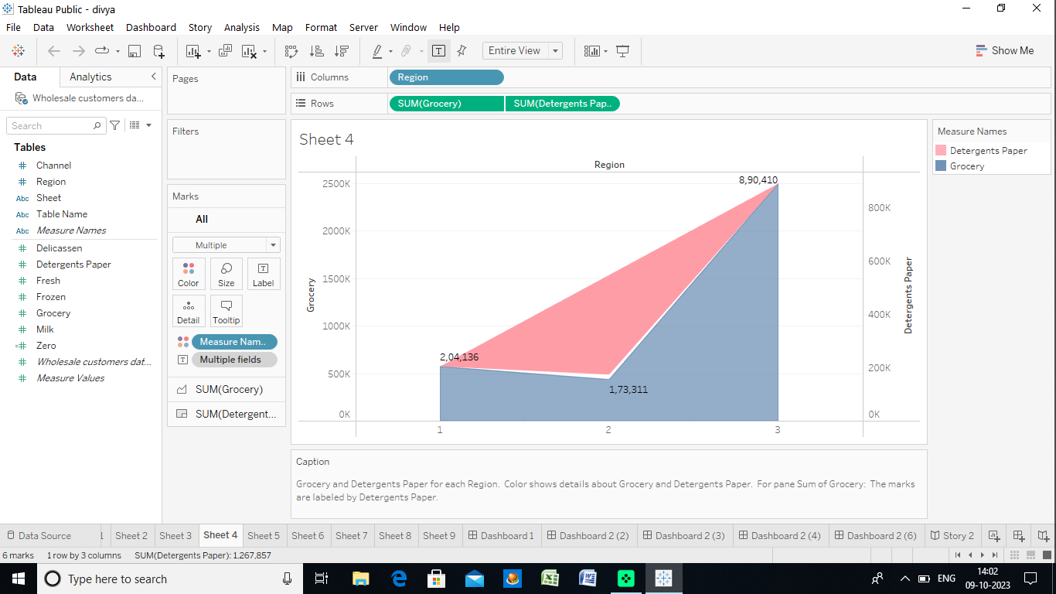

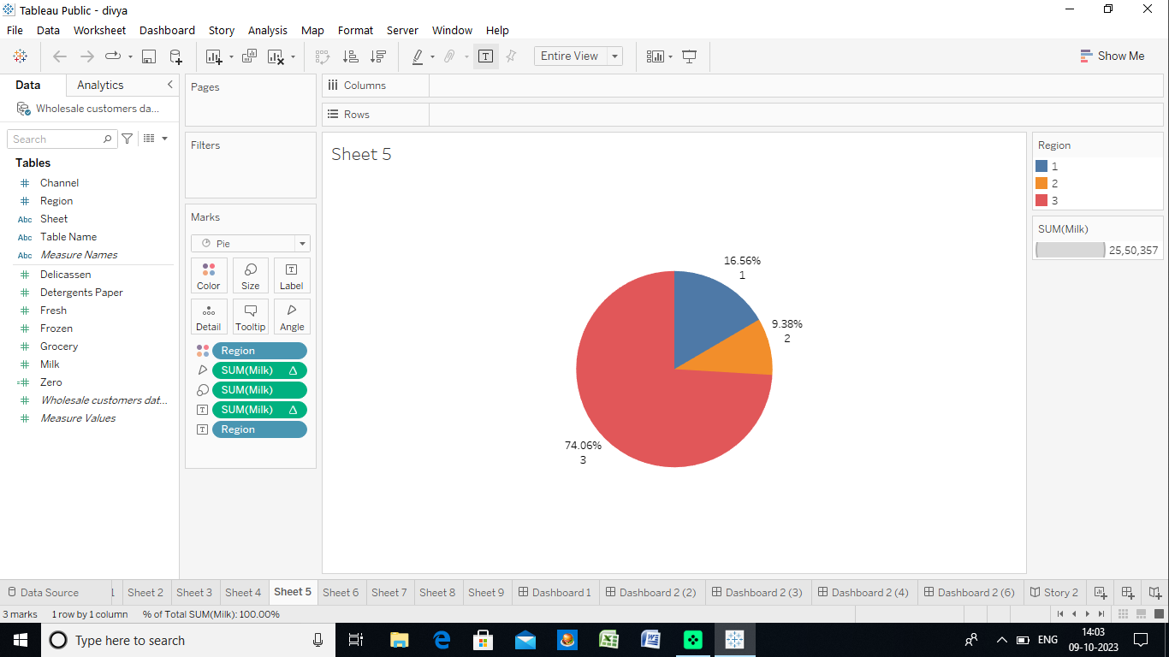

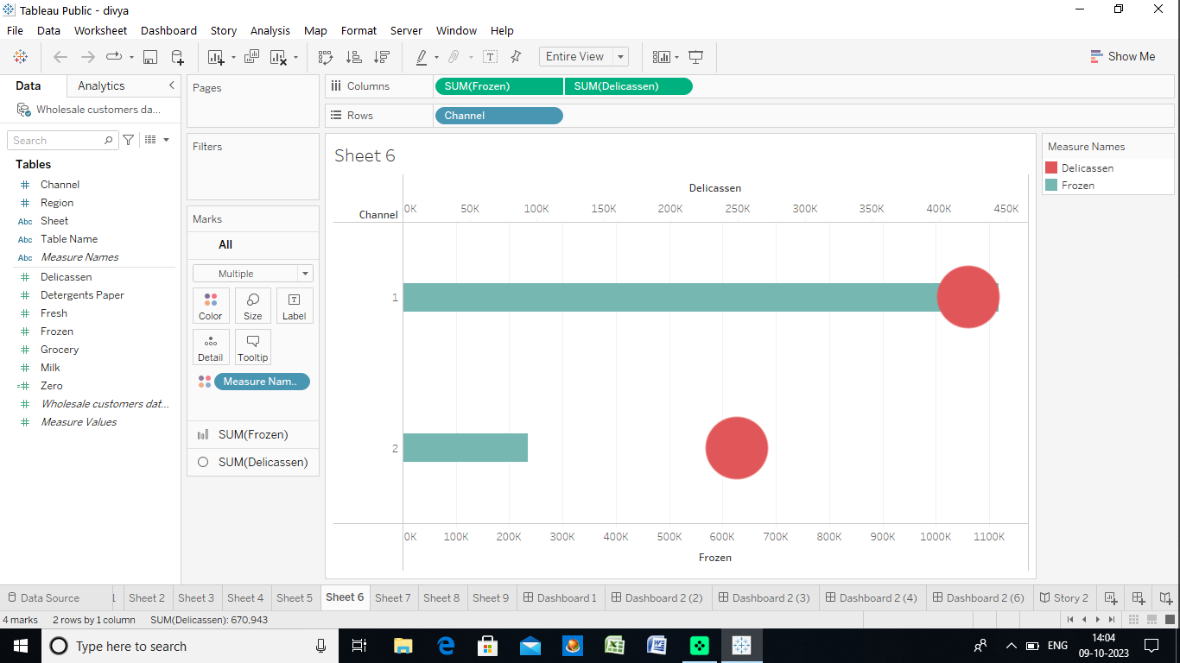

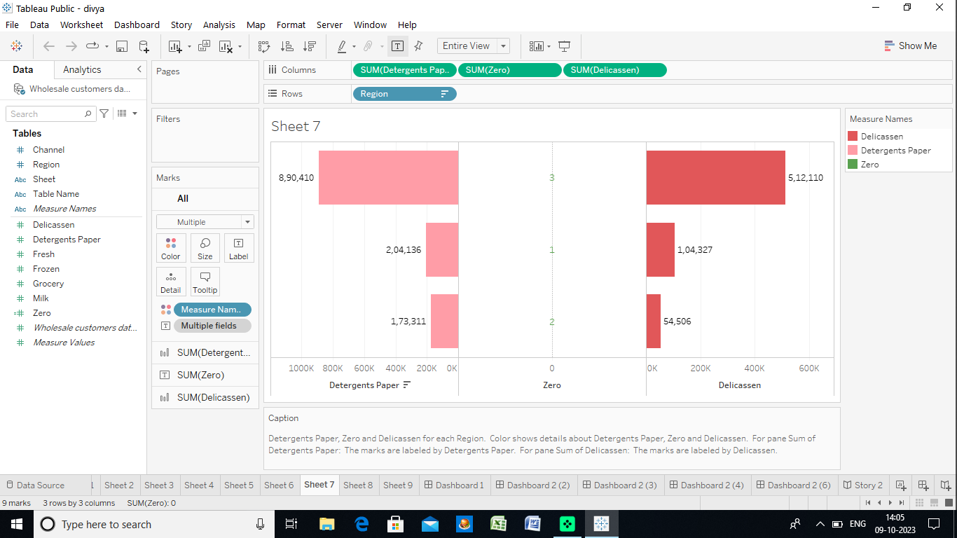

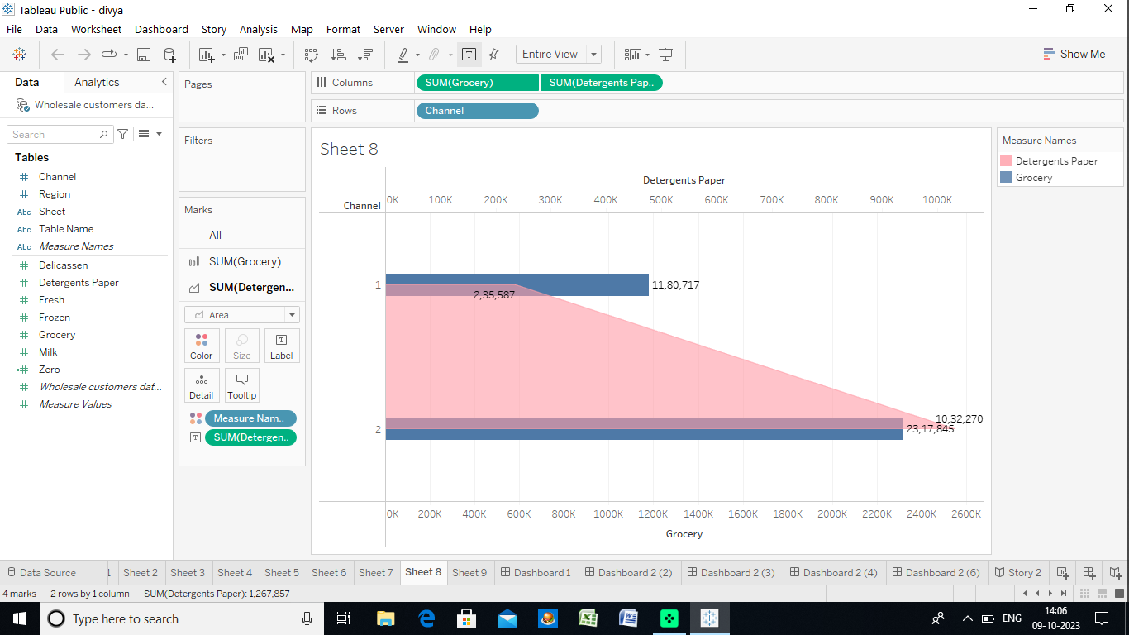

**DASHBOARD 1**

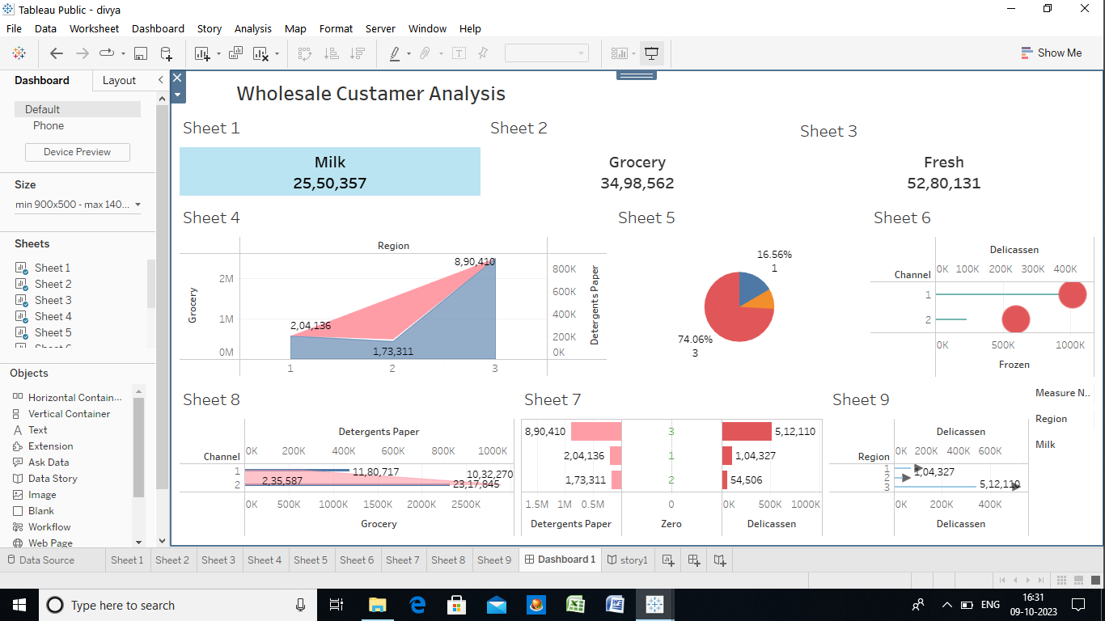

**STORY**

**Story 1.png**

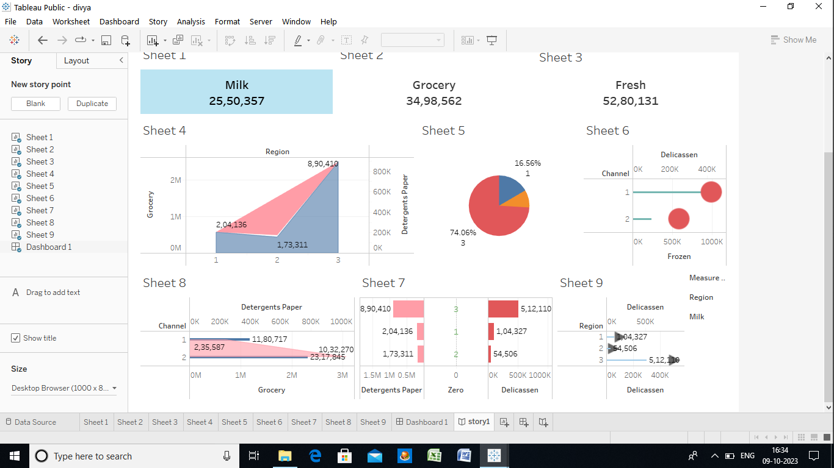

**OUTPUT**



1. **ADVANTAGE**

Market research analysis is a crucial component of a successful business strategy. It helps companies understand their target audience, evaluate market opportunities, and develop effective marketing campaigns. By conducting research, businesses can gain a competitive advantage by making informed decisions based on data-driven insights. The market research analysis also enables companies to identify gaps in the market, explore new customer segments, and adapt their offerings to meet changing consumer demands.

**PRIMARY AND SECONDARY RESEARCH**

To conduct market research analysis, businesses can utilize primary and secondary research methods. Primary research involves collecting new data directly from the target audience through surveys, experiments, or observational studies. On the other hand, secondary research involves analyzing existing data from various sources, such as industry reports, government publications, and academic studies. Both primary and secondary research provides valuable information that can contribute to a comprehensive market analysis.

**QUANTITATIVE RESEARCH METHODS**

SURVEY

Surveys are one of the most commonly used quantitative research methods. By designing and administering surveys, businesses can collect large amounts of data from a diverse group of respondents. Surveys allow companies to gather information about consumer preferences, buying behaviours, and satisfaction levels. The data collected can be statistically analyzed to identify trends, patterns, and correlations.

EXPERIMENTS

Experiments are conducted to test hypotheses and determine cause-and-effect relationships. By manipulating variables and observing the outcomes, businesses can gain insights into consumer responses to specific changes in their products, services, or marketing strategies. Experiments provide valuable data that can be

used to make informed decisions and optimize business processes.

FOCUS GROUPS

Focus groups involve bringing together a small group of individuals to discuss a specific topic or product. This method encourages participants to share their opinions, perceptions, and experiences, providing qualitative insights into consumer preferences and attitudes. Focus groups can uncover valuable information that goes beyond numerical data, offering a more holistic understanding of consumer

**ANALYZING AND INTERPRETING DATA**

Once the data is collected, market research analysts employ various techniques to analyze and interpret the findings. This process involves several stages, including data cleaning and preparation, statistical analysis, and data visualization.

1. **DISADVANTAGES**

Can be expensive. Implementing a market research strategy can be expensive, especially for smaller businesses. Requires significant time investment. May only target a small population . Need personnel to conduct research.

Information gathered is more than likely not going to be specific to the business and its needs.

1. **SIGNIFICANCE**

UNDERSTANDING CUSTOMER BEHAVIOR

Consumer research allows businesses to gain insights into behaviour , attitude, and buying patterns of their target audience. By analyzing this data, companies can make informed decisions about product development, marketing strategies, and even pricing.

Relying on gut feelings or assumptions can be risky in competitive market. Consumer research provides objective data that can guide decision-making, ensuring that your efforts are aligned with what your customers actually want.

PRODUCT INNOVATION

You can indentify emerging trends and adapt your products or services accordingly. This proactive approach to innovation can keep your business relevant and appealing.

**CONCLUTION**

In the above discussion, we have tried to give you the details about marketing insight and its importance. One of the most important benefits of marketing insights we learned is that it will strengthen the relationship between marketers and customers by providing the details needed to solve marketing problems and assist with marketing policy.

**FUTURE SCOPE**

Market future scope analysis is the process of researching where and how you can reach more potential clients or grow your revenue share.

**APPEMDIX**

https://drive.google.com/file/d/1KsNB7gDktlaGgjBbzr5s88DxtYmoTcNL/view?usp=drivesdk